INSTALLATION

1. Open command prompt (start menu --> type cmd)
2. pip install breeze_connect
3. pip install xlwings
4. pip install pyotp
5. pip install pandas
6. pip install requests
7. pip install ta
8. pip install pandas_ta
9. pip install flask

You can find your API and secret key from the API Portal.

**ICICI Login and Access Token**

1. Put api key, secret key and session key in icici_login.py

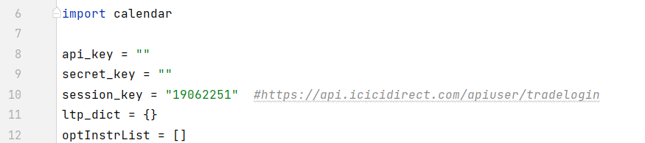

You can also refer to this:

https://pypi.org/project/breeze-connect/#place_order